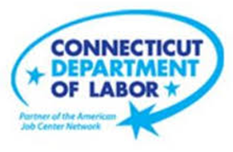

**NEW WEEKLY JOB POSTINGS FROM   
HELP WANTED ONLINE  
Office of Research**

**Week Ending March 19th, 2022: Weekly New Ads Slide to 8,640 But Remain Up Over The Year**  
WETHERSFIELD, March 18th, 2022 – During the week ending March 19th, 2022, there were 8,640 new postings, down 830 new ads from the week ending March 12th. More than half of this over the week top-line decline can be attributed to drops in Health Care & Social Assistance (-353 new ads), Educational Services (-225 new ads), and Finance & Insurance (-110 new ads). Five industries increased job ads and tempered this net decline, including Retail Trade (+126 new ads), Pro., Sci., & Tech. Services (+83 new ads), and Accommodation & Food Services (+48 new ads). Employers that had the most new job ads this week include Hartford Healthcare (447 new ads), Totalmed Incorporated (+146 new ads), and Walmart/Sam’s Club (117 new ads). Total job ads have fallen from the series high of over 12,000 new ads three weeks ago, but the most recent week is also up 47 percent over levels from four weeks ago. Over four weeks, 13 of 21 industries are up by 32% or more. The graph below illustrates the recent shifts in addition to how the averages of the past two months are much higher than corresponding levels from a year ago.  
  
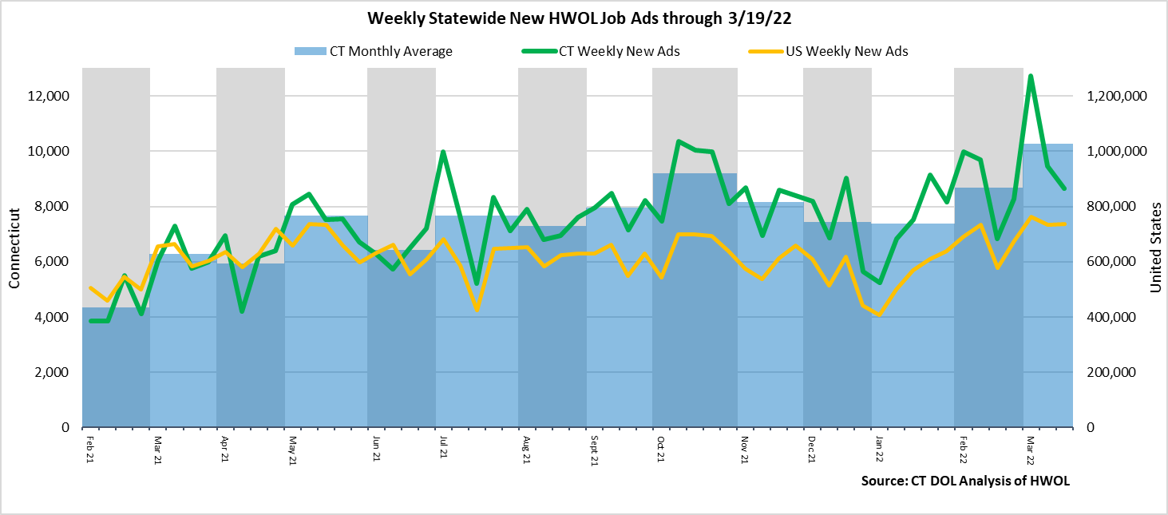

**Industries** with the most new postings include Health Care & Social Assistance, Retail Trade, and Finance & Insurance.

**Occupations** with the most new postings include Registered Nurses, Retail Salespersons, and Wholesale & Manufacturing Sales Representatives.

**Employers** with the most new postings include Hartford Healthcare, Totalmed Inc., and Walmart/Sam’s.

**The three industries with the most new job postings where:**

* **Health Care & Social Assistance** (1,957 new postings, -16% over the week)
* **Retail Trade** (769 new postings, +20% over the week)
* **Finance & Insurance** (687 new postings, -14% over the week)

   
 13 industries had job posting decreases over the week and 8 had increases. The 13 decreasing industries fell by a combined 1,170 new ads over the week and the 8 increasing industries grew by a combined 340 new ads. All but two of the 13 decreasing industries fell by 10% or more and 6 fell by 20% or more. The largest industry decrease occurred in Health Care & Social Assistance (-353 new ads) and the largest increase among the 8 increasing industries in Retail Trade (+126 new ads). Most industries had increases over four weeks, with the largest increases occurring within Health Care & Social Assistance (+808 new ads). Among the six industries with four-week decreases, the largest was Transportation & Warehousing (-131 new ads).  
  
 For more information on total job ads by industry for Connecticut and its labor market areas, see the monthly report available here: <https://www1.ctdol.state.ct.us/lmi/hwol.asp>

**New Job Postings by Occupation** 

**The occupations with the most new postings were:**

* Registered Nurses (707 new postings, -15% over the week)
* Retail Salespersons (227 new postings, -8% over the week)
* Sales Representatives, Wholesale and Manufacturing (177 new postings, -2% over the week)

**Employers with the Most New Job Postings**

Employers with the most new job postings during the week were mostly in Healthcare, Finance & Insurance, and Professional, Scientific & Tech. Services. The 25 employers shown above account for 19 percent of all new ads. Among the top 25 employers, 14 had over the week ad increase and 11 had decreases. The largest increasing employer over the week was Totalmed Inc. (+137 new ads) and the largest decreasing employer was Hartford Healthcare (-60 new ads). Over four weeks, 20 of 25 employers shown above had increases and 5 had decreases. The largest of each were Hartford Healthcare (+234 new ads) and Avangrid (-85 new ads).  
   
**What is HWOL?**The **Conference Board Help Wanted Online**® Data Series (HWOL) measures the number of new, first-time Online job postings and jobs reposted from the previous month for over 16,000 Internet job boards, corporate boards and smaller job sites that serve niche markets and smaller geographic areas. To view more HWOL data, go to: <https://www1.ctdol.state.ct.us/lmi/hwol.asp>